Practical 2:

UML Diagram for LMS

Use-Case Diagram
(fig. Use case diagram of admission management system)

Activity Diagram

[ .pdf, .docx, .doc, .zip, .xlsx]
Verify
(fig. Activity diagram for document upload)

Click on “Finish”
Click on “Next”
Click on “Home”
_{[ Get below 75%]}
_{[ Get above 75%]}
(fig. Activity diagram for online test)

Swimlane Diagram
_{Verify document size}
_{Verify document type}
_{Verify Document size}
(fig. Swimlane diagram for document upload)
Click on “Finish”
Click on “Home”
Click on “Next”
(fig. Swimlane diagram for online test)

Class Diagram
(fig. Class diagram for admission management system)

Sequence Diagram
(fig. Sequence diagram for admission management system)
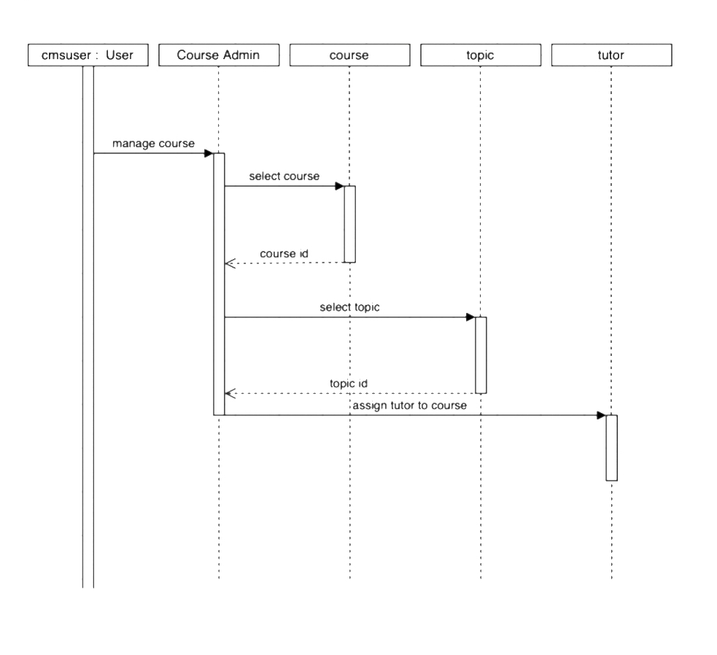
Request for tutor to course
assign course
(fig. Sequence diagram of course selection)

State Diagram
(fig. State diagram of course selection)
Valid
Successful
Fail
(fig. State diagram of fees payment)

